**Library Name** - Phone Code

**Library Version** - 1.0

**Library Release Date** –

**Library Overview**

Phone Code library provides access to a developer to add this into their own project, where user will get option to enter his/her mobile number. The main feature includes a list of phone codes of all the countries from where user can choose the country he/she belongs to and the Mobile code of that country will automatically added to the phone number field.

**GitHub Link** – <https://github.com/Applib-OpenHarmony/PhoneCode>

**Screenshot of Library**

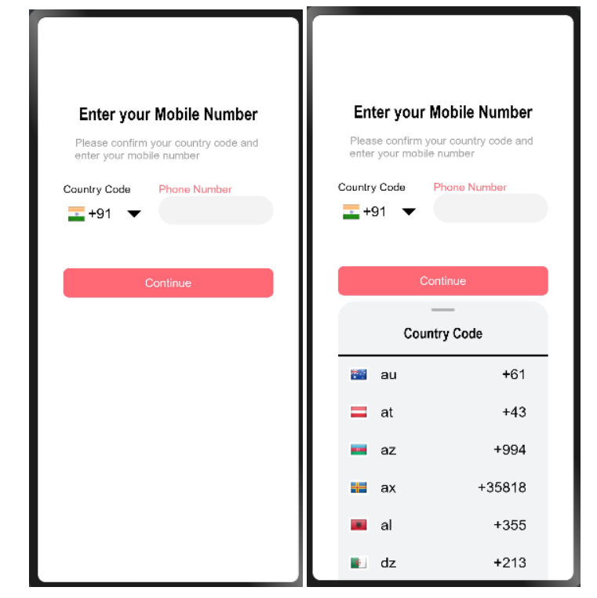

**Library Feature 1: Button**

A beautiful colored clickable button is provided underneath the input field, by clicking which user can submit his data into the server

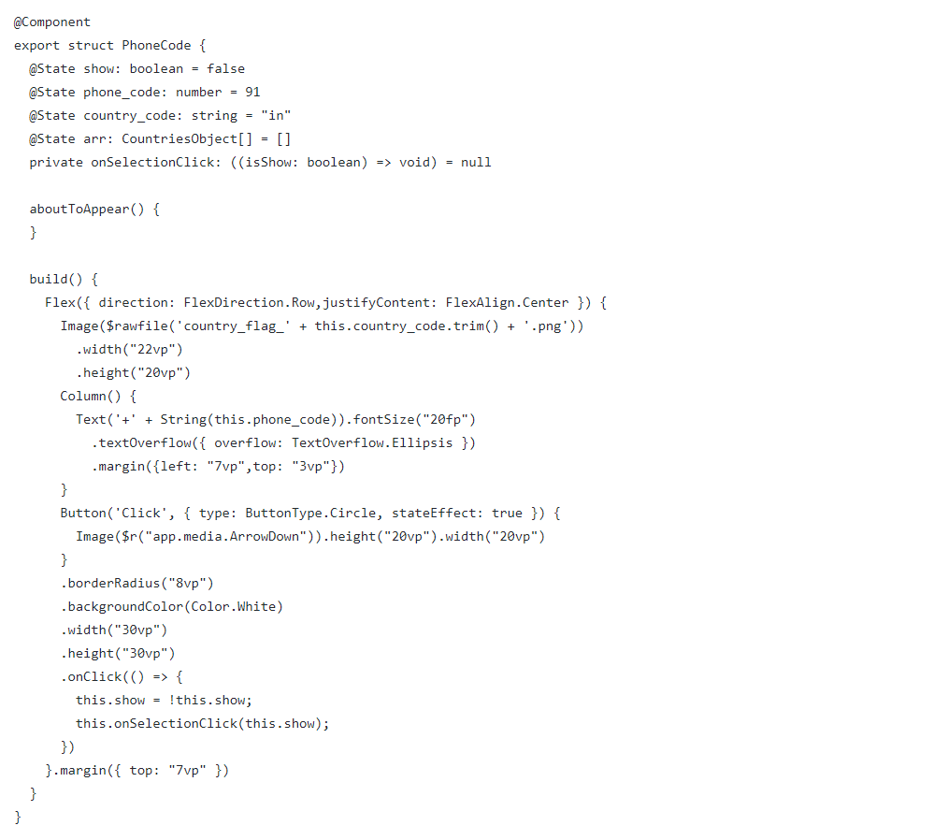

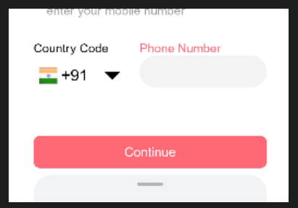

**Library Feature 2: Panel**

Upon clicking the dropdown button a panel will pop up from the bottom of the screen which displays the name, phone code and the country flag icon of the countries. User can select his/her country and the phone code of that country will automatically added up to the required field.

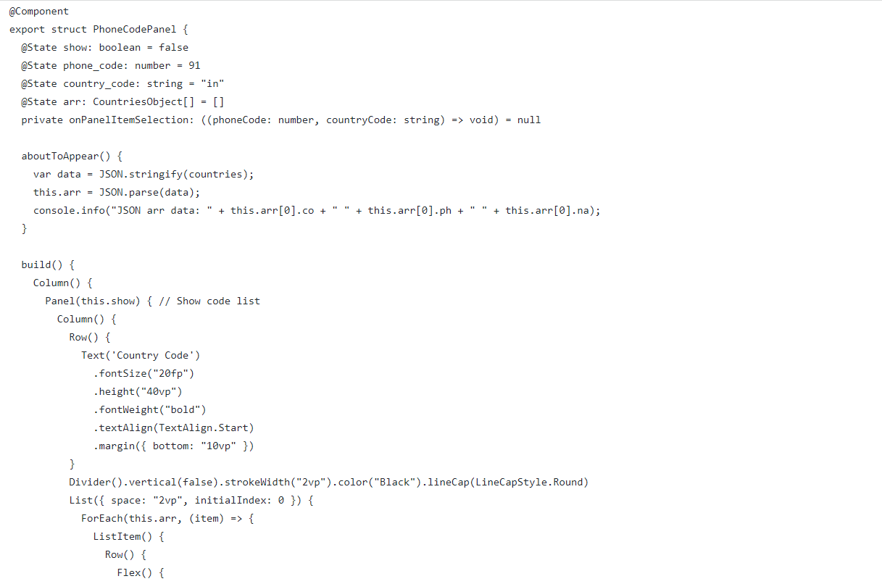

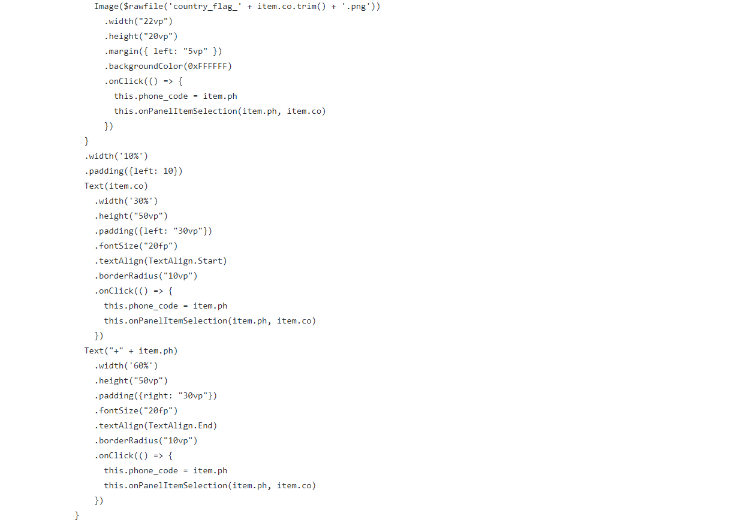

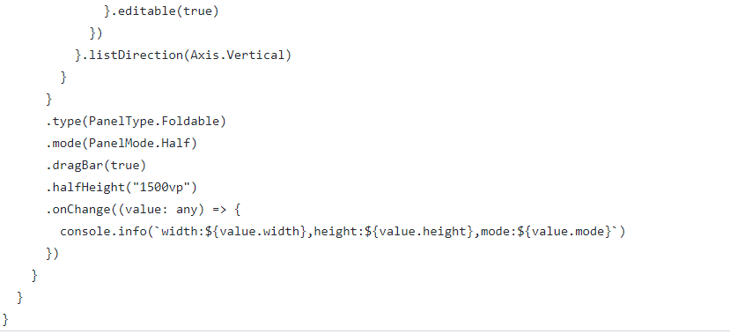

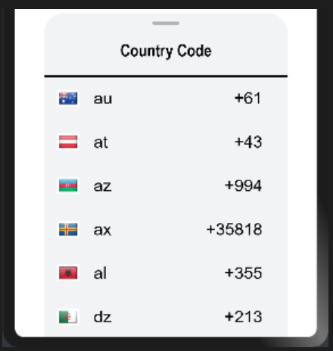

**Advance features that can be implemented into the library -**

1. Voice search can be integrated so that user don’t have to pick the country name each time from the panel, instead he/she can do a voice search and the data will be filled up
2. Application can seek permission to use the user's current location and the phone code of that country in which the location exists can be filled up automatically.

**Open Source License**

Licensed under - [Apache-2.0 license](https://github.com/applibgroup/applibgroup/blob/main/LICENSE)

**Conclusion**

1. It is a very useful Library which can save your lots of time by importing it directly into your App
2. It is easy to use and very user friendly and its UI is very much specific
3. Specific fields can be customized according to the need of the project